ECE 579 Intelligent Systems, Fall 2024
Final Project Report
Project title: Multimodal Data with Anomaly techniques for Object detection and tracking in Autonomous Driving.
Revathy Iswarya Sekaran (11625243): Data Preprocessing, Model Development and Anomaly detection technique, Project Presentation.
Aksheya Kannan Subramanian (25502870): Model Development, Model Evaluation.
Dharshani Anandkumar (82653870): Model Development, Technology Research, Report Writing.
- Introduction
  - This project develops a real-time object detection and anomaly detection system for autonomous vehicles (AVs) using high-resolution camera images from the Waymo Perception dataset. Accurate detection of vehicles, pedestrians, and other road users is critical for AV safety. By leveraging YOLOv5 and YOLOv8 models, the system identifies these objects and detects anomalies to ensure safety and reliability. The system incorporates visualization and evaluation metrics to validate its robustness across diverse driving scenarios.
- Description of technologies related to your project (e.g. technologies related to moving vehicle detection)
  - YOLO(You Look Only Once)-YOLOv5 and YOLOv8: A real-time object detection model known for its speed and accuracy, used for identifying vehicles and pedestrians in camera images. YOLO’s grid based approach predicts bounding boxes and class probabilities simultaneously.
  - Waymo Perception Dataset: A high-resolution dataset tailored for autonomous driving tasks, including camera-only 3D object detection
  - Google Cloud Tools: gsutil: Used to efficiently transfer the Waymo Open Dataset for processing and model training.
Model Architecture:
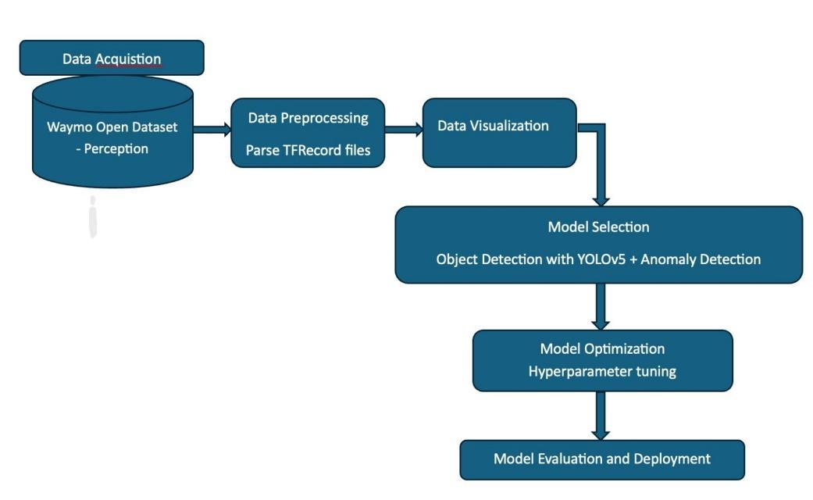
- Methods used in your project
  - Data Acquisition: Transferred the Waymo Open Dataset using Google Cloud’s gsutil tool for efficient handling of large TFRecord files.
  - Data Preprocessing: Parsed TFRecord files to extract camera images, ensuring compatibility with YOLOv5.
Data: 80 Waymo TFRecord files with over 56,000 images.
Sample Image from a frame in a TFRecord:
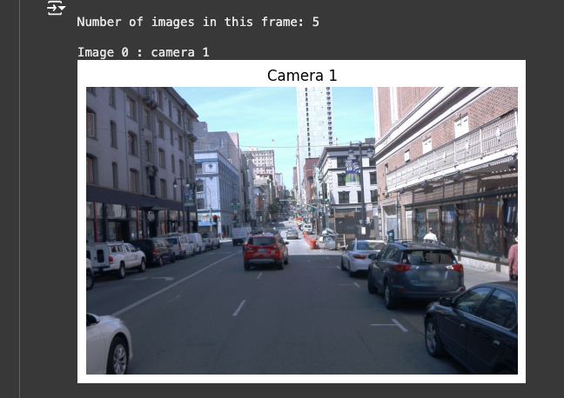
  - Object Detection(YOLOv5):
- Implemented YOLOv5 for detecting vehicles and pedestrians in camera images.
- The model Outputs detected objects with bounding boxes, their class labels(eg., Car, truck, bicycle or fire hydrant), and a confidence score that represents the model’s certainty in the prediction.
Results of YOLOv5: 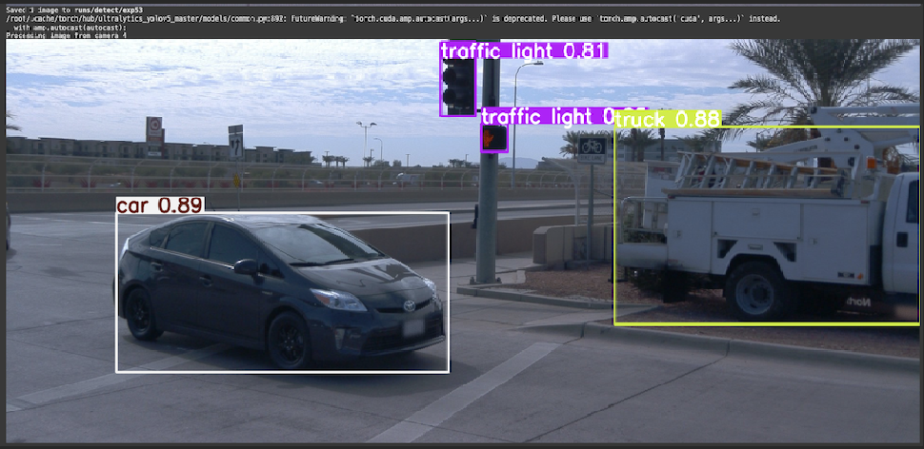
  - Anomaly detection(YOLOv8):
- Implemented YOLOv8 for anomaly detection, defining expected object classes and setting a confidence threshold[0.5] to flag anomalies.
- Classified images into anomaly and non-anomaly categories based on detection results.
YOLOv8 Object Detection and Anomaly detection results for first 2 Frames: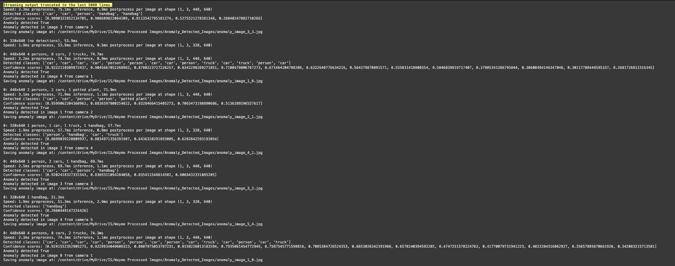
  - Visualization: Visualized detected objects with bounding boxes using Matplotlib for qualitative analysis
  - Prediction:
    - The model successfully detected multiple vehicles(trucks, cars etc.,) in random images with high confidence score, generating bounding boxes and class labels.
    - Anomalies were flagged based on the presence of unexpected objects in the scene, indicating the model’s capability to distinguish between normal and anomalous conditions.
Prediction results of random unseen images with and without vehicles: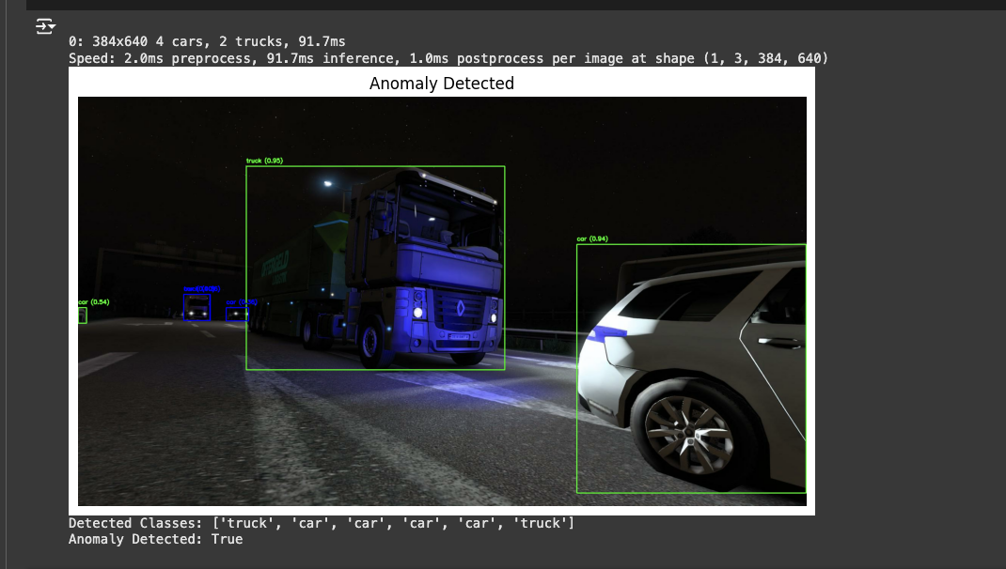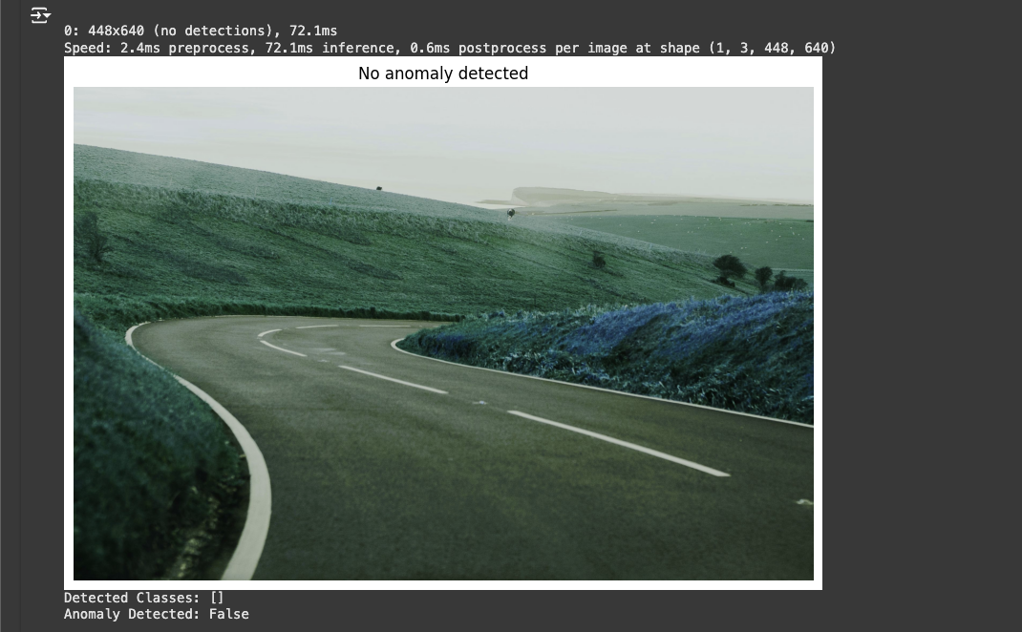
  - Metrics Evaluation:
- Plotted confidence score distribution to assess model reliability.
- Calculated IoU (Intersection over Union) between predicted bounding boxes to evaluate detection alignment.
Proportion of Anomalies Vs Non-Anomalies: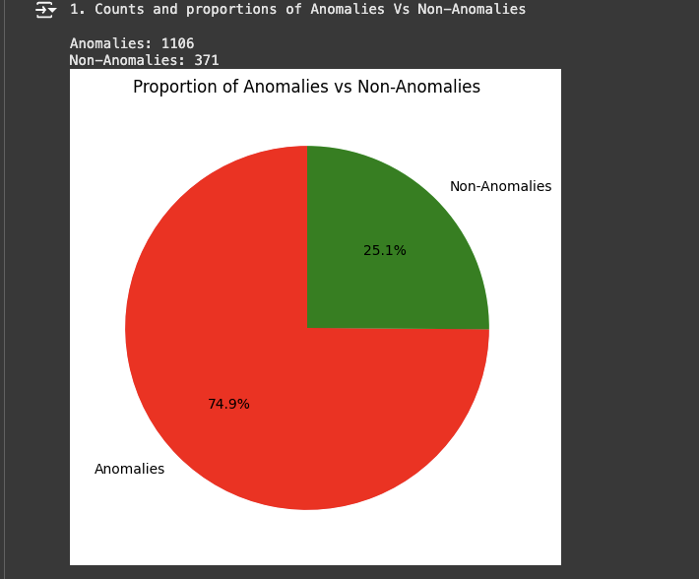
Confidence Score Distribution: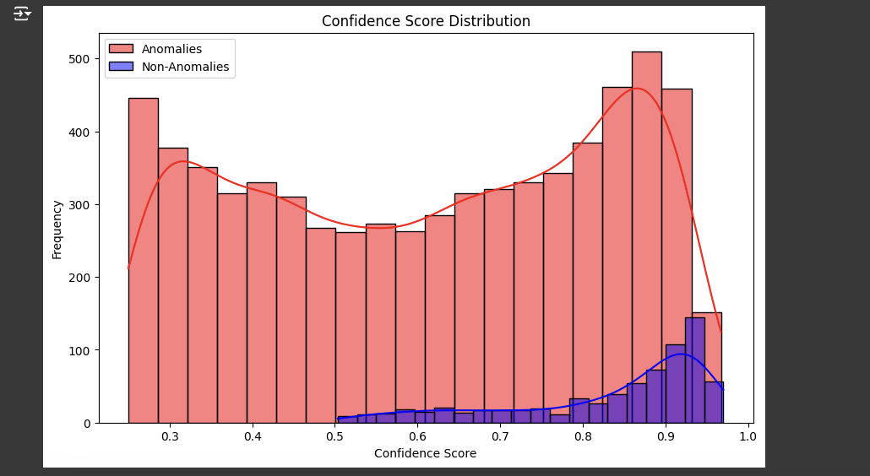
Inference: The confidence score distribution shows that the YOLOv8 model is highly reliable in identifying non-anomalous instances, with scores clustering near 1.0. Anomalous instances display a broader range of confidence scores, indicating variability in detection certainty. This demonstrates the model's ability to effectively distinguish between normal and abnormal cases.
IoU(Intersection over Union): is a metric used to measure the overlap between two bounding boxes. In the absence of ground truth, IoU is calculated between the model's predicted bounding boxes to evaluate their overlap and consistency.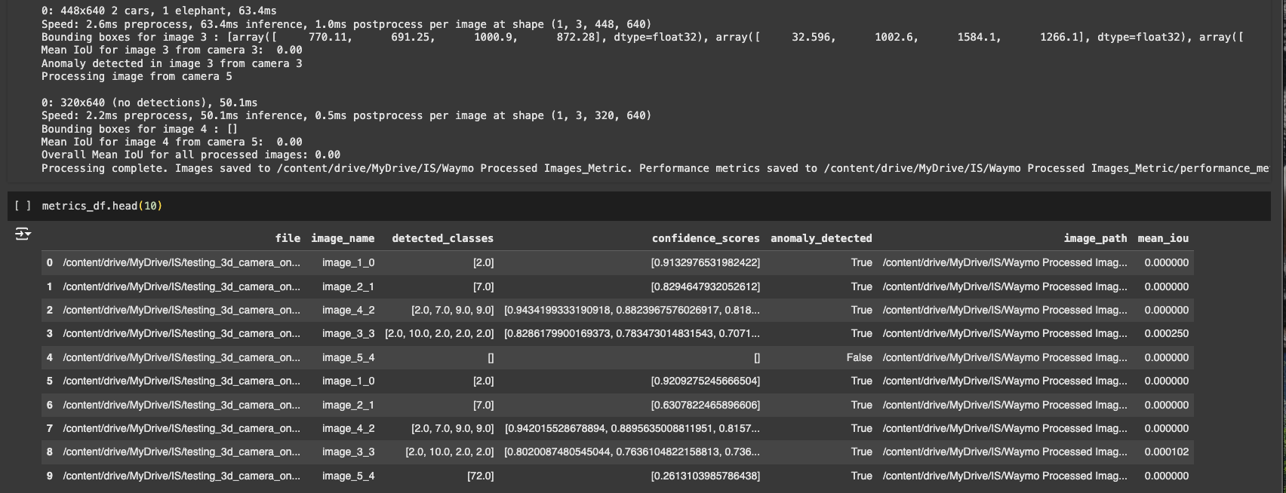

- Experiments
  - 2D Detection: YOLOv5 and YOLOv8 were trained on Waymo images and evaluated for detecting vehicles and pedestrians and anomalies in real-time.
  - Model Performance Evaluation: Confidence score distributions and IoU metrics were used to assess model performance. IoU evaluated the overlap of predicted bounding boxes ensuing accurate detection alignment.
  - Robustness Evaluation: Tested the system’s performance on diverse Google images to ensure accurate object and anomaly detection.
- Conclusion
- This project successfully developed a real-time object and anomaly detection system for autonomous vehicles using YOLOv5 and YOLOv8.It demonstrated reliable object detection and anomaly classification with high confidence scores and bounding box alignment, despite the absence of ground truth data. The system’s performance was evaluated using confidence scores distribution and IoU metrics. Working with large datasets enhanced our skills in data handling, model implementation, and visualization. This experience highlighted the potential for further enhancements, such as incorporating 3D detection models and tracking algorithms for more comprehensive system performance.
Code Drive Link: https://drive.google.com/drive/folders/1HU9wZHy_-Or-bSUVr9MwXCv2Zbm_1Hc_?usp=share_link
- References
[1] Li, X., et al. (2024). "YOLO-Vehicle-Pro: A Cloud-Edge Collaborative Framework for Object Detection in Autonomous Driving under Adverse Weather Conditions." arXiv preprint. Link to paper
[2] IEEE. (2023). "Autonomous Vehicle: Obstacle Avoidance and Classification with YOLO." IEEE Conference Publication. Link to paper
[3] Hossain, M. S., Sohel, F., Shiratuddin, M. F., & Laga, H. (2019). A comprehensive survey of deep learning for image captioning. MDPI. Link to paper
[4] W. E. Villegas, S. Sánchez-Viteri and S. Luján-Mora (2024) "Real-Time Recognition and Tracking in Urban Spaces Through Deep Learning: A Case Study," in IEEE Access, vol. 12, pp. 95599-95612 Link to paper
[5] Khan, S., Rahman, A. U., Jan, B., Farman, H., Muhammad, K., Anwar, H., & Sangaiah, A. K. (2022). “Comparing YOLOv3, YOLOv4 and YOLOv5 for Autonomous Landing Spot Detection in Faulty UAVs”. Sensors, 22(2), 464. Link to paper
[6] Mittal, U., Chawla, P. & Tiwari, R. (2023). “EnsembleNet: a hybrid approach for vehicle detection and estimation of traffic density based on faster R-CNN and YOLO models”. Neural Comput & Applic 35, 4755–4774 Link to paper
[7] Wang, J., & Chen, Y. (2021). "Multi-Sensor Fusion with YOLO for Enhanced Detection in Autonomous Vehicles." Sensors, vol. 21, no. 10, pp. 3396. Link to paper
[8] Y. Hui, J. Wang and B. Li (2024) "WSA-YOLO: Weak-Supervised and Adaptive Object Detection in the Low-Light Environment for YOLOV7," in IEEE Transactions on Instrumentation and Measurement, vol. 73, pp. 1-12, Art no. 2507012 Link to paper
[9] P. Wang, Y. Yin, S. Fu, B. Liu, F. Yang and X. Wang (2023) "YOLOv5s-FBG: A Small Object Detection Method in Complex Road Background," 2023 International Conference on Blockchain Technology and Applications (ICBTA), Beijing, China, pp. 52-59 Link to paper
[10] Y. Cai et al. (2021) "YOLOv4-5D: An Effective and Efficient Object Detector for Autonomous Driving," in IEEE Transactions on Instrumentation and Measurement, vol. 70, pp. 1-13, Art no. 4503613. Link to paper

